

Techwiz-05 Project Documentation on Decor Vista



|  |  |  |
| --- | --- | --- |
| **Team Name:** | **Tech Master** | |
| **Batch:** | **2212D** | |
| **Techwiz-05 Project:** | **Decor Vista** | |
| **S.no** | **ENROLLMENT NO.** | **STUDENT NAME.** |
| **1.** | **1438583** | **Abdul Basit** |
| **2.** | **1436456** | **Haris Imtiaz** |
| **3.** | **1439929** | **Zubair Desai** |
| **4.** | **1395237** | **Shezil Umer** |

Acknowledgement:

We are deeply grateful to the **TechWiz project team at Aptech Head Office** for giving us the opportunity to work on this interesting and wonderful project focused on **home decor and interior design for Decor Vista**. Their support and resources were instrumental in the successful execution of this project.

Our heartfelt thanks also go to the **e-Project team** for entrusting us with this task, enabling us to explore new learning opportunities and enhance our skills.

This project has been a tremendous learning experience. It reinforced our technical knowledge through practical application, guided by the mentorship that kept us on track and motivated. This hands-on experience has greatly boosted our confidence to face future challenges, including job interviews, where we can demonstrate our comprehensive understanding of the subject.

Finally, we extend our sincere appreciation to all of our colleagues for their valuable suggestions and continuous encouragement during this journey.

Thank you.

Synopsis:

**Decor Vista - Interior Design Laravel Website Synopsis:**

The **Decor Vista Interior Design Laravel Website** is a full-featured, modern web application tailored to meet the needs of an interior design and home decor business. Developed using the Laravel framework, the website aims to streamline operations, improve client engagement, and simplify the management of design projects. The website offers a professional interface, seamless navigation, and secure backend processes to provide a superior experience for both clients and the Decor Vista team.

**Key Functionalities:   
Project Management and Consultation Booking:**-Clients can schedule consultations or request design services online.  
 -A calendar system for managing project timelines and booking appointments.  
-Automated reminders for upcoming consultations or design project milestones.

**Portfolio Showcase:**

-Display past and ongoing projects with high-resolution images, descriptions, and client testimonials.  
-Filter projects by type (residential, commercial, office, etc.) for easy navigation.  
-Allow clients to "like" and comment on portfolio items for social proof.

**Service Management:**

-Offer a detailed breakdown of services such as full interior design, furniture selection, color consultations, and custom decor.

-Pricing packages for different levels of design involvement (basic, premium, custom).

-Clients can request quotes based on the specific services they need.

**Client Management:**-Maintain a detailed profile of each client, including design preferences, project history, and communication records.  
-Enable clients to track the status of their ongoing projects from their dashboard.  
-Manage contracts, invoices, and project updates all in one place.

**Product Catalog and E-Commerce Integration:**

-Showcase home decor products, furniture, and accessories that clients can purchase directly from the website.  
-Integration with secure payment gateways for a smooth shopping experience.  
-Set up custom collections (e.g., “Modern Living Room,” “Cozy Bedroom”) for easy browsing. **Reporting and Analytics:**

**Payment and Billing:**

-Enable clients to pay for design services and products directly through the website.  
-Generate and send invoices for both design services and decor products.  
-Track payments and provide clients with a full payment history in their profiles.

**Blog and Design Tips:**

- Create and share blog posts on the latest interior design trends, home decor tips, and project highlights.  
-Provide value to clients with expert advice on colour schemes, furniture placement, and seasonal decorating ideas.  
-Engage clients through comment sections and social sharing options.

**Marketing and Promotions:**

-Create and manage special promotions, discounts, and exclusive offers for clients.  
-Send newsletters and marketing emails to promote new services or featured products.  
-Integrate with social media to drive traffic and increase brand visibility.

**Reports and Analytics:**

**-**Track sales, client inquiries, project success rates, and other business metrics with detailed reports. **-**Analyse client preferences to offer targeted services or products. **-**Export data for financial reporting or strategic planning.

**Security and User Roles:**

-Role-based access control to secure sensitive information such as financials and client data. **-**Regular backups to ensure data security and integrity. **-**Encryption of all transactions and sensitive data.

PROJECT ANALYSIS:

**Project Overview:**

The **Decor Vista Interior Design Management System** aims to develop a comprehensive web application to streamline and enhance the operations of a home decor and interior design business. By utilizing modern web technologies, this project will facilitate project management, client interaction, design services, product inventory, and billing processes, offering an all-in-one solution for **Decor Vista**.

**Objectives:  
Efficient Project and Consultation Scheduling:**

-Provide clients with an easy-to-use platform for booking design consultations and scheduling project meetings.  
-Allow the **Decor Vista** team to manage timelines, project phases, and client interactions effectively.

**Staff and Inventory Management:**

-Enable efficient management of design team members, project roles, and timelines.  
-Track home decor product inventory and furniture stock to ensure timely delivery and avoid shortages.

**Client Relationship Management (CRM):**

-Maintain detailed client profiles, including design preferences, project history, and communication records.  
-Offer personalized design recommendations based on client preferences and past projects.

**Billing and Reporting:**

**-**Implement a billing system that generates invoices for both design services and products. **-**Provide comprehensive reporting tools for insights into project performance, client satisfaction, and financial metrics.

**Target Users:  
Business Owners/Managers:**

-Oversee all operations, manage design projects, and make business decisions to drive growth.

**Business Owners/Managers:**

-Oversee all operations, manage design projects, and make business decisions to drive growth.

**Design Team:**

-Interior designers, decorators, and support staff responsible for executing client projects and managing daily operations.

**Clients:**

-Individuals or businesses seeking professional interior design services and home decor products.

**Technology Stack  
Backend:**

**-**Laravel PHP Framework for a scalable and secure server-side application.

**Frontend:**

-HTML, CSS, JavaScript, and a front-end framework (e.g., Bootstrap) for a responsive and user-friendly interface.

**Database:**

-MySQL or another relational database for efficient management of design projects, client information, and inventory data.

**Key Features:  
Project and Consultation Management:**

-Manage design projects with clear timelines, real-time updates, and automated notifications.  
-Schedule consultations and design reviews with ease through the platform.

**Staff and Inventory Control:**

**-**Track staff assignments, manage team availability, and assign project tasks. **-**Monitor decor product inventory levels and furniture availability to ensure timely fulfillment of client orders.

**Client Profiles:**

**-**Maintain personalized client profiles with detailed preferences, project history, and design feedback.  
-Enable clients to access their project status and updates through their profiles.

**Billing and Invoicing:**

**-**Generate automated invoices for design services, decor purchases, and consultation fees. **-**Offer clients secure online payment options via integrated gateways.

**Reporting and Analytics:**

-Provide comprehensive reporting on sales, project timelines, client satisfaction, and overall business performance to support data-driven decisions.

**Conclusion:**

The **Decor Vista Interior Design** is designed to revolutionize the way home decor and interior design businesses operate. By offering seamless project management, efficient client relations, and streamlined billing, the platform will serve as a comprehensive solution to drive business growth, improve client satisfaction, and enhance overall operational efficiency.

PROBLEM STATEMENT:

**Introduction:**

**Decor Vista** is a prominent home decor and interior design business offering a wide array of services, including personalized interior design consultations, space planning, furniture selection, and the sale of exclusive home decor products. As the business grows, it faces several operational challenges, including managing multiple design projects, tracking product inventory, and maintaining accurate client records.

To address these challenges, an **Interior Design Management System** will be developed to enhance operational efficiency, improve the client experience, and streamline business processes for **Decor Vista**. By focusing on essential functions like project management, client relations, inventory control, and staff coordination, the system will enable **Decor Vista** to optimize its workflow and concentrate on delivering outstanding design solutions and decor services to its clientele.

PROJECT REQUIREMENTS:

The following are the key features and functionality expected from the application:

**Home Page:**

**Feature:**

-Engaging introduction to Decor Vista’s services, showcasing various interior design projects and trends.

**Implementation:**

-Design a clean, modern layout using Blade templates.  
-Incorporate a hero section with a slideshow or carousel to showcase project images and featured designs.  
-Include key business information (mission, design philosophy, and unique services).  
-Add a call-to-action (CTA) for booking consultations or contacting the team.

**User Authentication and Access Control:**

-**Feature:** Secure login for different user roles like **admin**, **designer**, and **client** with role-based permissions.  
-**Implementation:**

* Use Laravel's authentication system for login and registration.
* Define roles (e.g., admin, designer, client) using spatie/laravel-permission or built-in role-based middleware.
* Clients can view their project status, designers can update projects, and admins can manage everything.

**Project Management:**

**-Feature:** Allow clients to view project progress, design drafts, and timelines.

**-Implementation:**

* Create a **project model** to track each design project.
* Clients can log in to view progress, upload room photos, and provide feedback.
* Designers can upload design drafts, set project milestones, and track completion.

**Consultation and Booking Management:**

-**Feature:** Clients can book consultations and interior design services directly through the website.

-**Implementation:**

* Set up a booking system to allow clients to choose available dates and times for consultations or home visits.
* Automated notifications for booking confirmations and reminders (via email).

**Portfolio Management:**

-**Feature:** Display Decor Vista’s completed projects as a portfolio gallery to attract potential clients.

-**Implementation:**

* Implement a portfolio section where project details (images, design descriptions) can be uploaded by admins or designers.
* Allow visitors to browse completed projects and filter them by room type, style, or design category.

**Client Management:**

-**Feature:** Maintain a client database with details like project history, preferences, and contact information.

-**Implementation:**

* Create a client profile section where designers can log important information (styles preferred, materials, etc.).
* Clients can update their preferences and contact info via their user dashboard.

**Design Trends and Blog:**

-**Feature:** A blog section to feature design trends, tips, and home decor ideas to engage visitors and potential clients.

-**Implementation:**

* Set up a blog or news section where admins can post articles and design tips.
* Use a WYSIWYG editor like TinyMCE for easy content management.

**Reporting and Analytics (for Admins):**

-**Feature:** Generate reports on bookings, project completion rates, and client engagement.

-**Implementation:**

* Use Laravel’s Eloquent to query and generate reports on services, clients, and bookings.
* Display analytics on which design services are most popular, client feedback trends, and project timelines.

**Payment and Invoicing:**

-**Feature:** Manage client payments for design services, consultations, and purchases (if applicable).

-**Implementation:**

* Integration with payment gateways for smooth payment processing.
* Generate invoices for services provided (consultations, full project designs).
* Clients can view invoices and payment history in their dashboard.

**Admin Panel:**

-**Feature:** A user-friendly admin panel to manage content, clients, projects, and staff.

-**Implementation:**

* Use Laravel for a backend dashboard where admins can manage users, projects, blog content, and inventory.

**Contact Us:**

-**Feature:** A page where potential clients can contact Decor Vista for inquiries or service requests.

-**Implementation:**

* A simple contact form that captures client details (name, email, phone, message).

**Feedback and Testimonials:**

-**Feature:** Allow clients to submit feedback or post testimonials about their experience with Decor Vista.

-**Implementation:**

* A feedback form that allows clients to rate services, give comments, and post testimonials.
* Admins can review and approve testimonials for display on the site.

**Other Considerations:**

* **Mobile Optimization**: Ensure the entire website is mobile-responsive, using Bootstrap to adapt the design across devices.
* **Security:** Focus on securing client data, especially sensitive information like payment details, using HTTPS, input validation, and Laravel’s security features.
* **Performance:** Used caching (Redis or Laravel Cache) to speed up loading times, particularly for image-heavy pages like the portfolio.

SCOPE OF THE WORK:

The scope of the **"Decor Vista" Home Decor Website** project focuses on creating a sophisticated and user-friendly web platform tailored to meet the specific needs of an interior design business. The primary objective is to showcase Decor Vista’s portfolio of projects while providing clients with a seamless experience for booking consultations and managing their interactions with the design team. The website will include a visually engaging home page with featured projects, service offerings, and a dynamic portfolio gallery. In addition, it will offer personalized client profiles to track project details, design preferences, and consultation history. For efficient operations, staff management tools will allow designers to manage schedules and tasks, while inventory management will track decor items and materials. The system will also integrate secure online payment options for consultations and services, as well as provide automated notifications for booking confirmations and project updates. Comprehensive reporting and analytics features will deliver insights into client behavior, project timelines, and sales trends. Designed to be responsive, the website will ensure a seamless experience across all devices, while maintaining strict security measures to protect sensitive client data. Ultimately, the **Decor Vista** website aims to enhance client engagement and streamline project management, delivering a modern and efficient solution for the interior design business. FLOWCHART/SITEMAP:

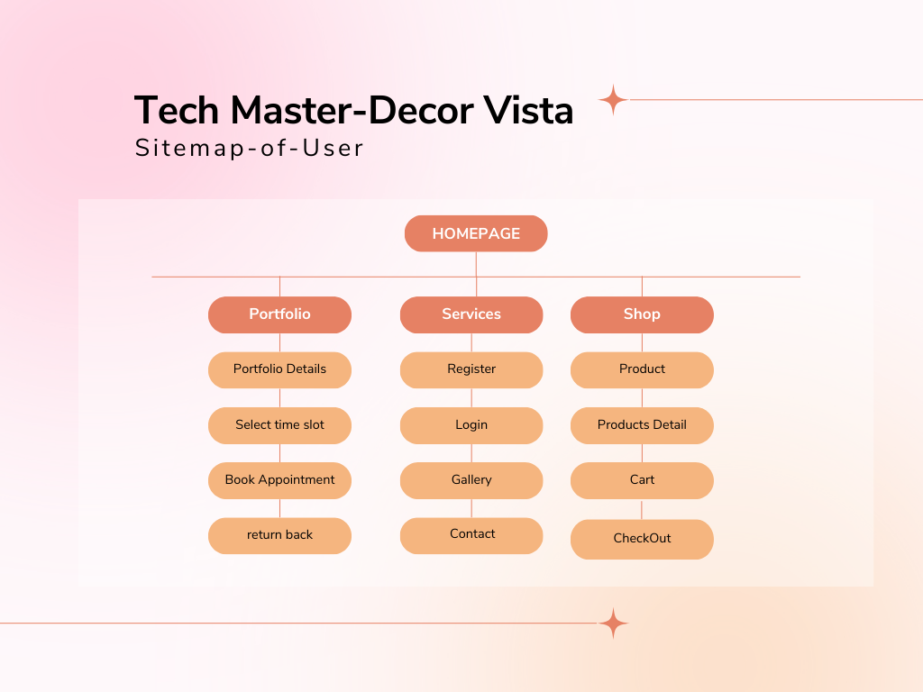

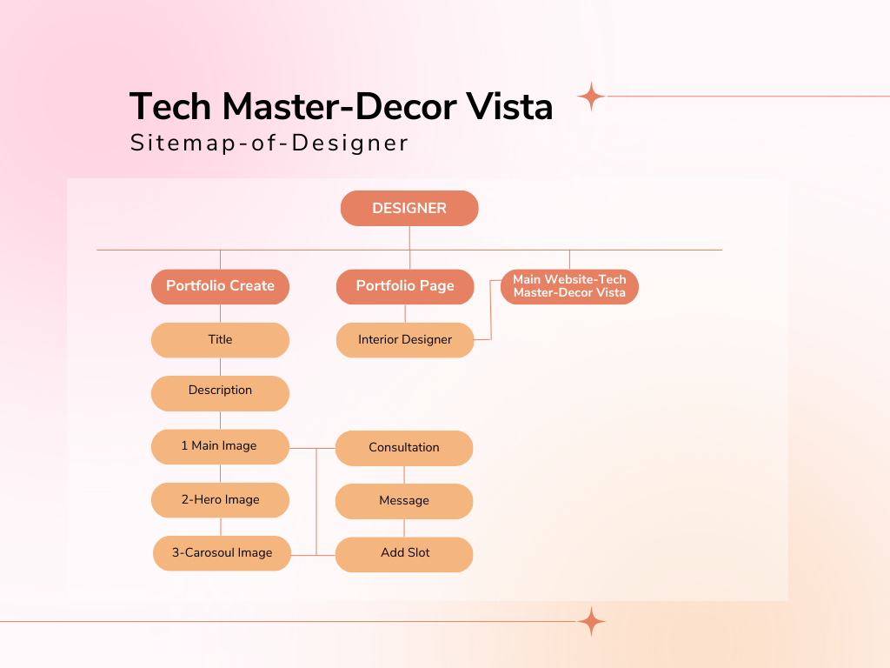

Ho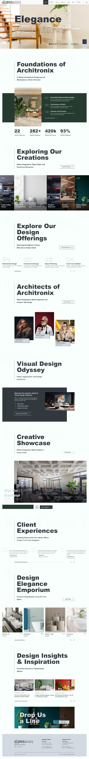me:

Portfolio:

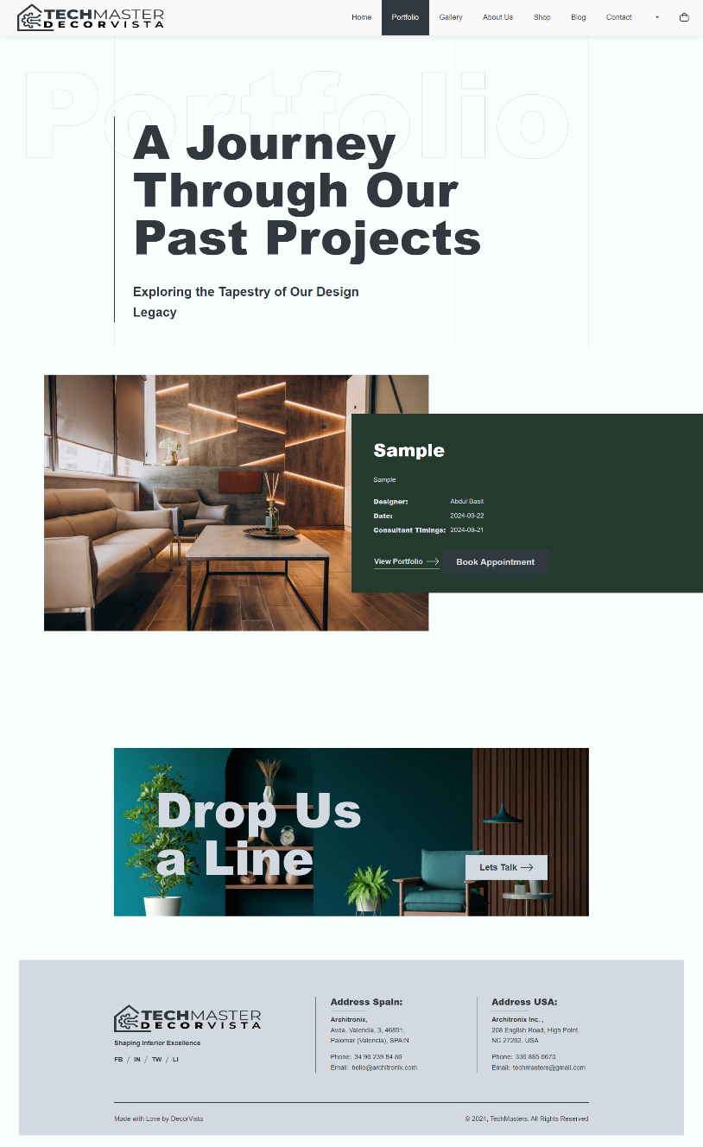

Shop Page & Cart Page;

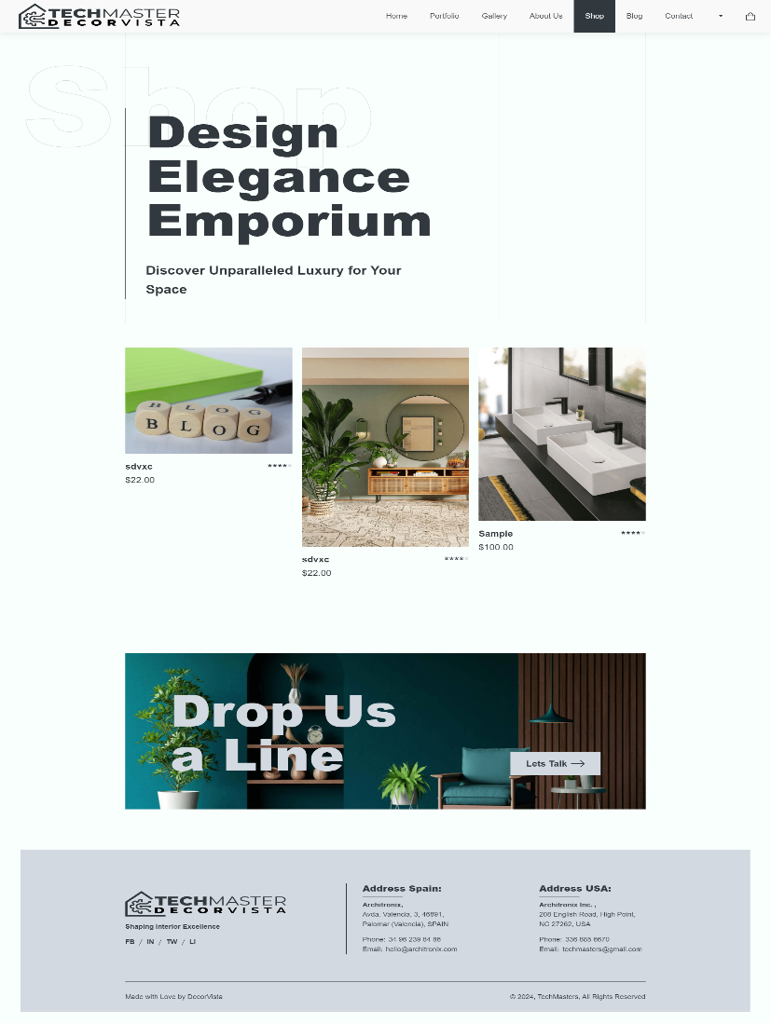

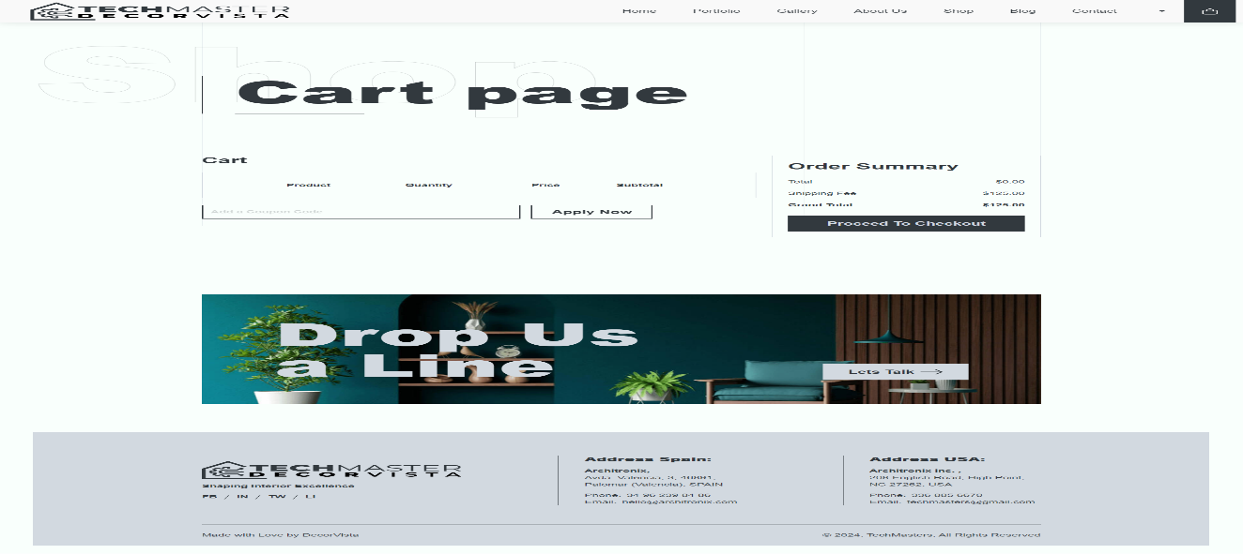

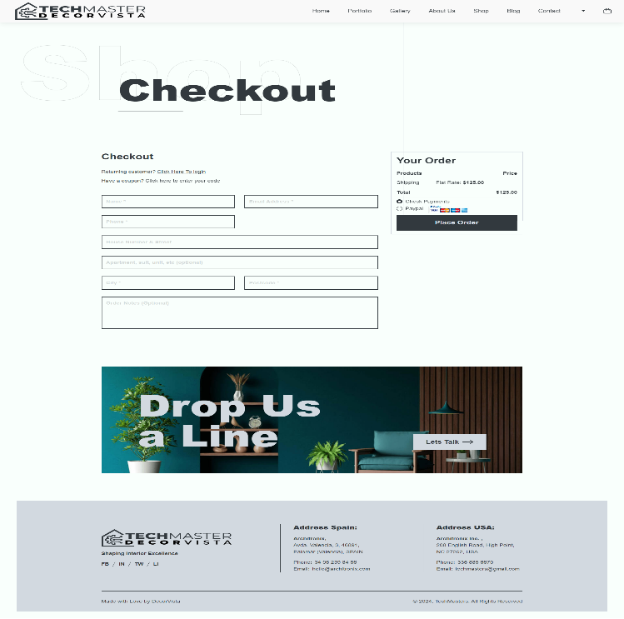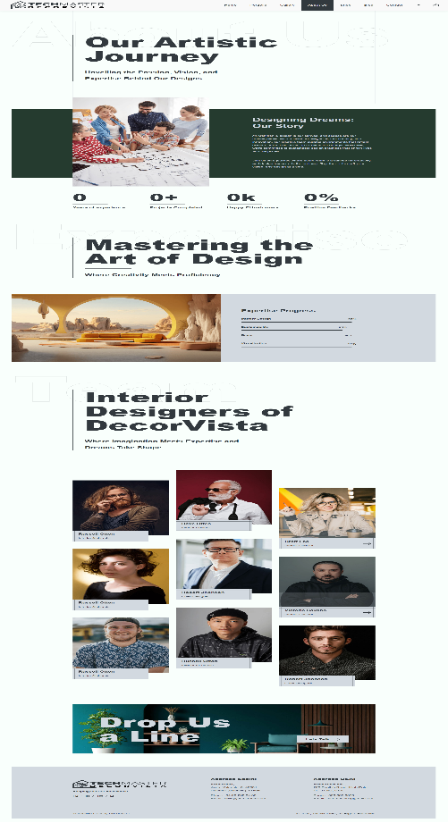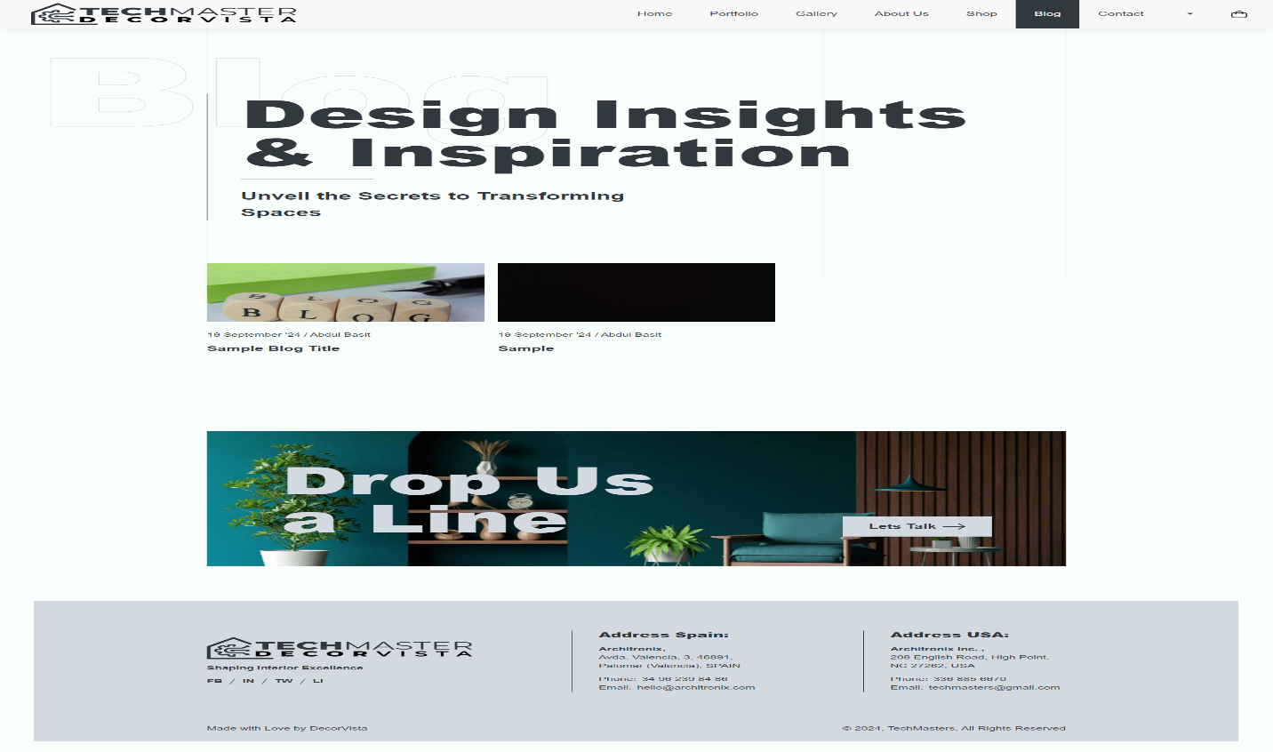 Blog Page & About us: Page & Check out:

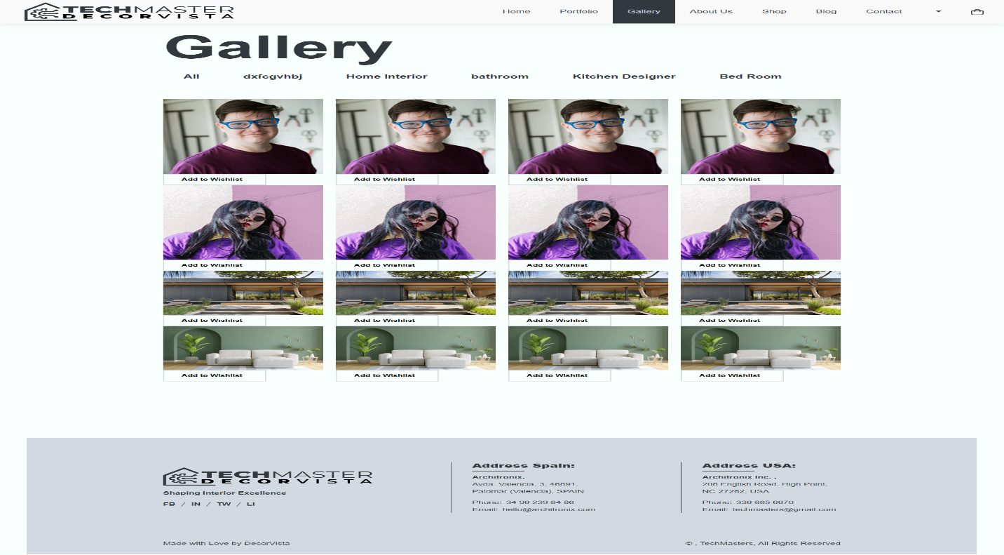Gallery Page:

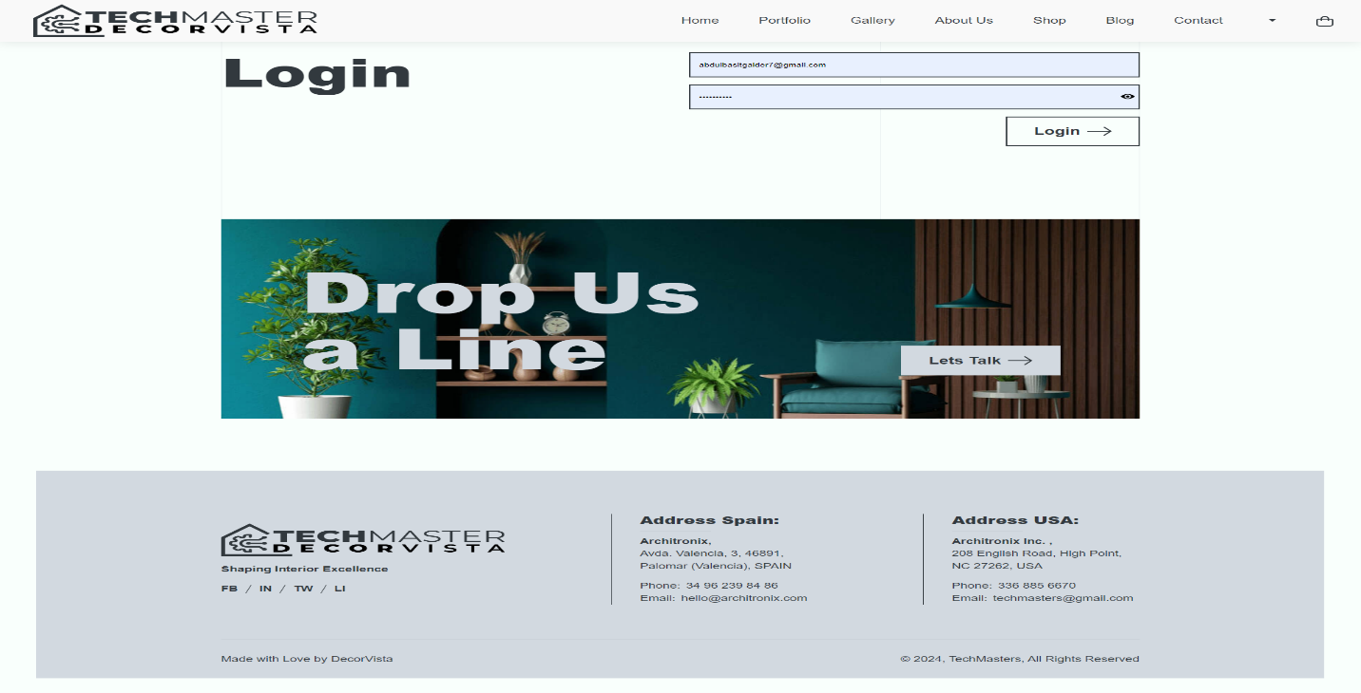Login Page:

Registration Page:

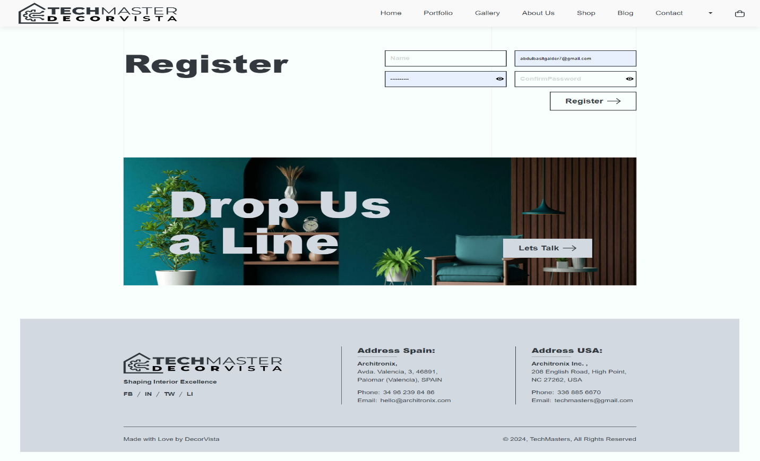

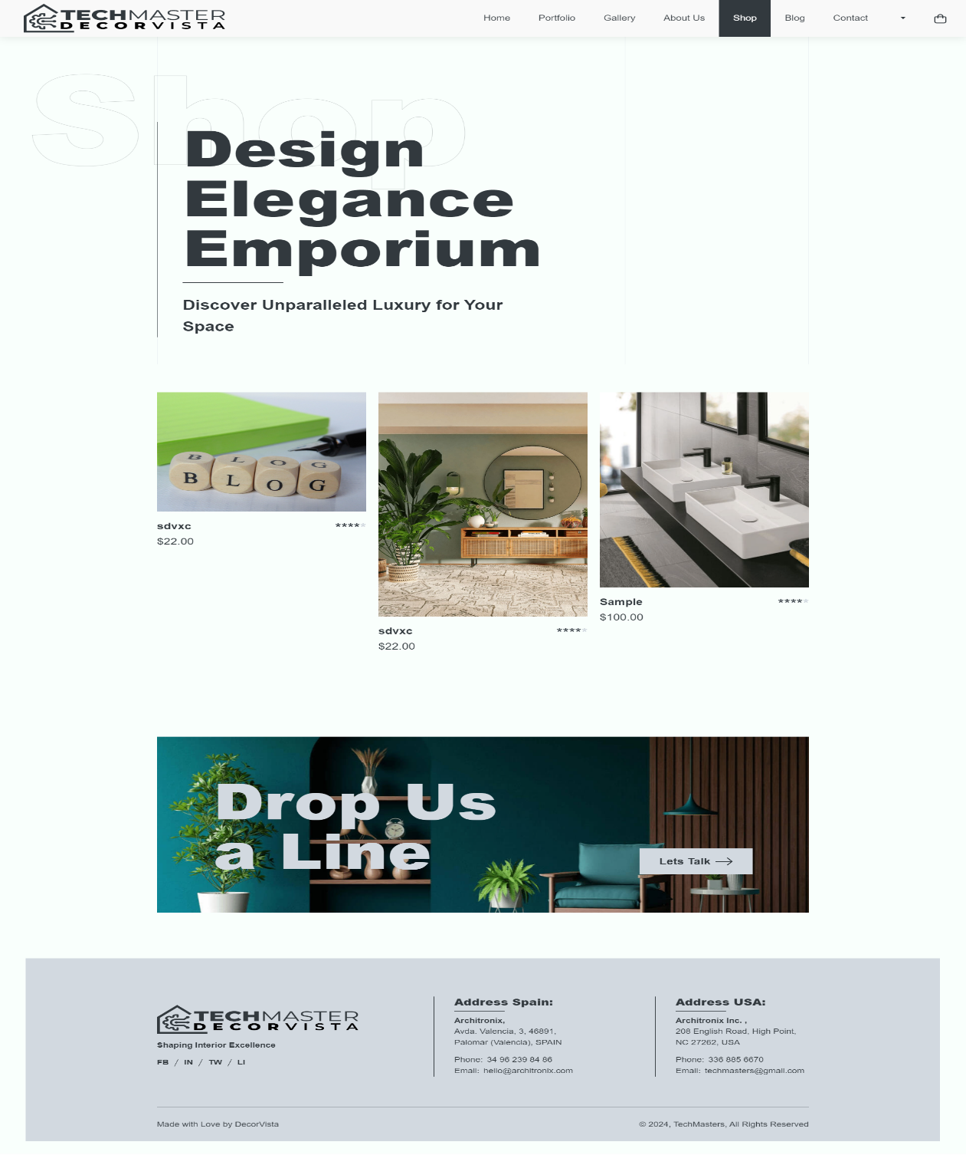Product Page: